# The Regulatory Accelerator

In this lesson we will learn about the regulatory accelerator. How to install and how to set up a team to process the regulatory terms and create relationships to our existing business glossary and information assets.A screenshot of a cell phone

**Description**:

The InfoSphere® Regulatory Accelerator reduces the hassle of complying with new regulations by reducing the amount of manual effort required to comply. The service:

* Uses machine learning to extract key terms, definitions, policies, and controls from regulatory documents
* Helps you visualize the different initiatives that your team must undertake to comply with the regulations
* Creates a glossary of related terms that you can import into your enterprise data catalog to govern the regulated data
  1. Log onto the IBM Cloud Pak for Data using your provided credentials and URL https://services-uscentral.skytap.com:18065/Zen

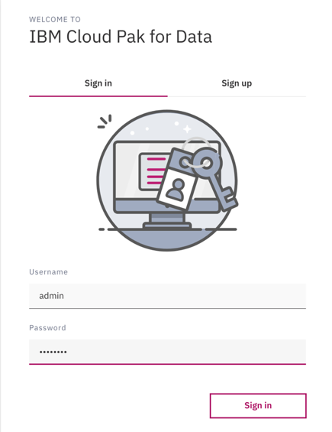

* 1. To check to see if the Regulatory Accelerator is installed navigate to the add-ons page. If the Regulatory Accelerator is installed, then it will show as enabled.

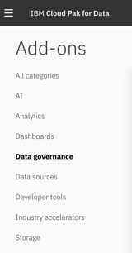

* 1. To install the Regulatory Accelerator follow the instructions that are provided here: <https://docs-icpdata.mybluemix.net/docs/content/SSQNUZ_current/com.ibm.icpdata.doc/iira/enable-iira.html>
  2. Once the Regulatory Accelerator is installed you can start working with the add-on by navigating to the projects menu and selecting New Project, Select the Regulatory Project radio button and provide a name for the project then click on OK

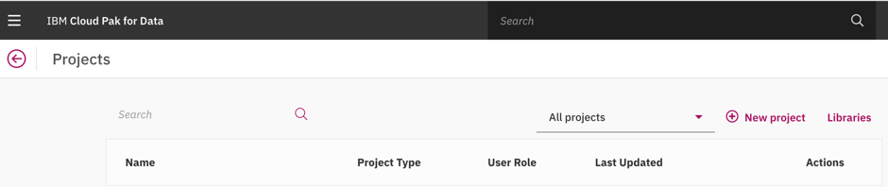

* 1. The new Regulatory Project will be opened. Select the industry relevant for your regulatory initiative (we will use Banking & Finance) then click on continue. A screenshot of a cell phone

     Description automatically generated
  2. Select the regulation you want to work with (we will use GDPR), then click on Continue.

* 1. Select Your Business Glossary to use for the mapping. At this point we could create a collection to use to hold our information assets but for this exercise we will assume the glossary is mapped to information assets to only a mapping of the regulatory terms to the business terms is needed. So just click on the Sample container database and then click on next

* 1. The Regulatory Project opens to the Map to Business Terms tab. To add a collaborator to the project, click on the + sign under “Your Team in the top right

* 1. A new collaborator can be added to by Clicking Add Collaborator

* 1. A screenshot of a cell phone

     Description automatically generatedSelect you Data Steward user and add it as a collaborator to the project with the Mapper role and click on Add
  2. After adding the user click on assign terms of the collaborators page to assign the Regulatory terms, by default the regulatory term assignment is split between the added users. We could change this but for now we won’t

* 1. Return to the Business Term Mapping tab, the select the first regulatory term to map, unique identification. The regulatory term is shown with some descriptive information and the subject tags on the left. Select the Subject tag – Personal Data. ON the right the machine learning algorithm provides some matches in the enterprise business glossary for the regulatory term selected. The appropriate business terms should be selected then the mapping can be submitted.

* 1. The accelerator will then move onto the next regulatory term to be mapped. Pressing the browser back arrow will take you to the overview page. A summary of the current project is shown. The Number of terms mapped the progress for the team as a percentage. If the user has review permissions, then the mappings can be reviewed for each of the Mappers on the project.

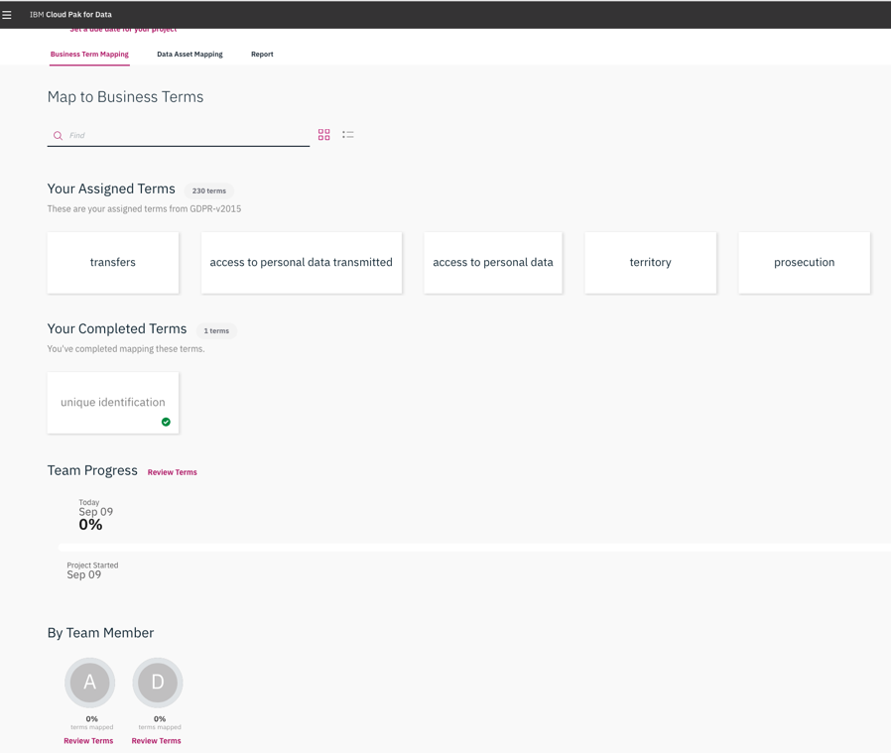

* 1. In the role of reviewer, a user can click on any of the collaborators at the bottom of the page to review any mappings they have created. Clicking on a regulatory term gives the user access to the mappings and these can be changed and saved if desired.

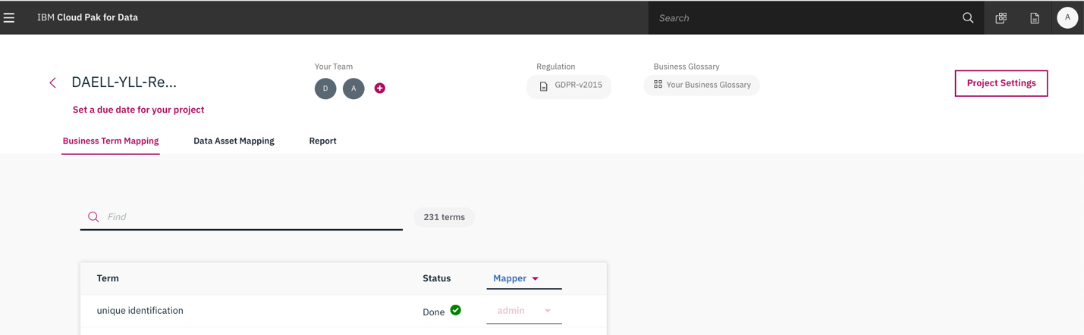

* 1. Click on the Report tab. A summary is shown of the percentage of the regulatory terms that are mapped can be seen. Also, a report of the mapping relationships is available that can be filtered to show aspects of the mapping based on the subjects, regulatory terms and data assets/business terms.

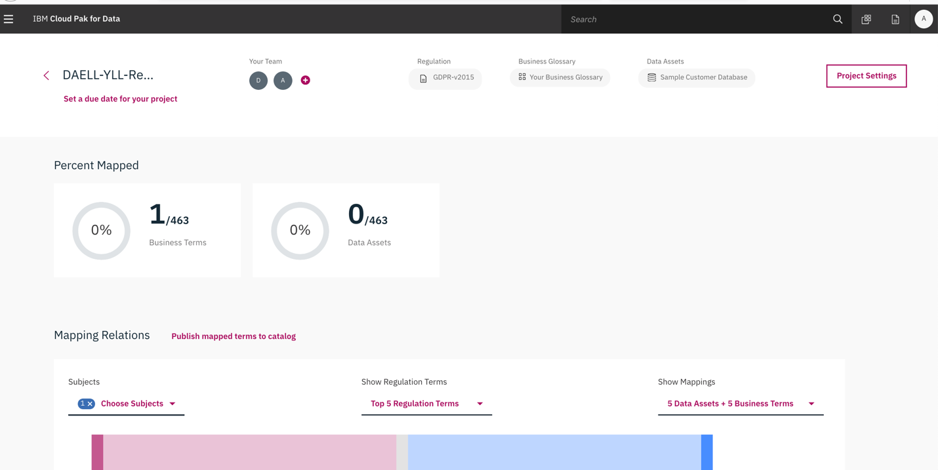

* 1. Click on the Published mapped terms to catalog text to publish the regulatory terms and their mappings to the enterprise glossary. A success message is shown when the terms are published.

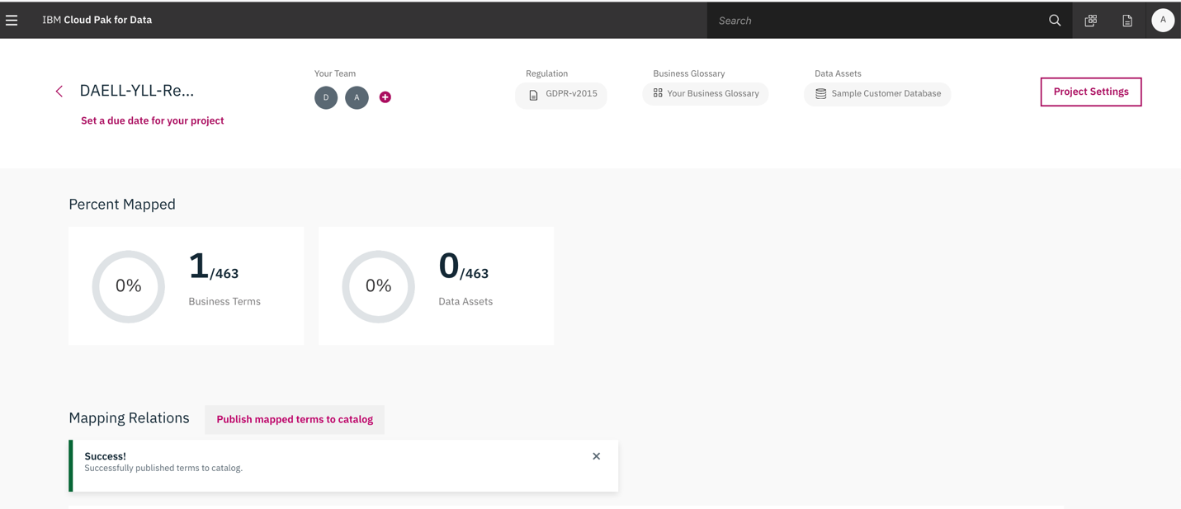

* 1. From the main menu select the business glossary menu option. This will open the glossary on the Categories tab. In the search panel search for GDPR to find the newly added GDPR category.

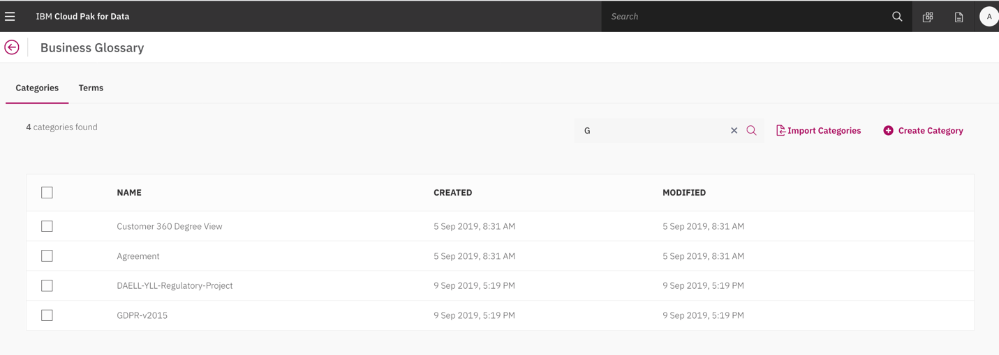

* 1. Select the GDPR-v2015 category to show the details. The context for the regulatory term contains the name of the regulatory project. Select the terms menu item in the top left. The regulatory term we mapped earlier should be present. Select the term to show its details.

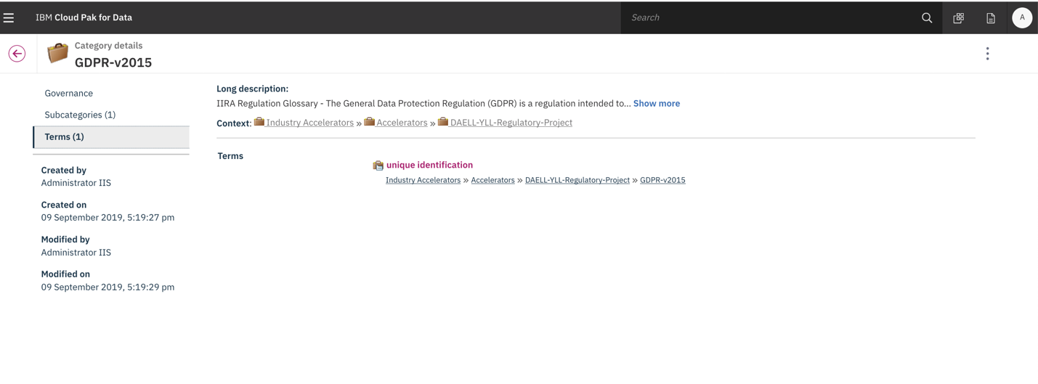

* 1. The regulatory term shows other categories that this term is referenced from in the GDPR regulations. 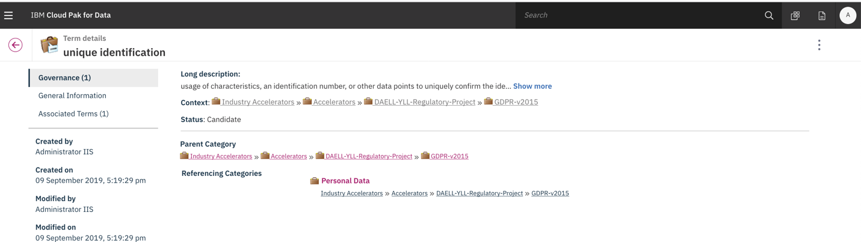
  2. Switch to the associated terms section to show the enterprise glossary term that we mapped to.

